
Perth Modern School
Semester One Examination, 2011

Question/Answer Booklet

Student Name SOLUTIONS

Teachers Name ______________________

Year Group__________________________

MATHEMATICS
3A/3B
Section Two:
Calculator-assumed

Student Number: In figures

In words

Time allowed for this section
Reading time before commencing work: 10 minutes
Working time for this section: 100 minutes

Material required/recommended for this section

To be provided by the supervisor
This Question/Answer Booklet
Formula Sheet (retained from Section One)

To be provided by the candidate
Standard items: pens, pencils, pencil sharpener, eraser, correction fluid, ruler, highlighters

Special items: drawing instruments, templates, notes on two unfolded sheets of A4 paper, and up to three calculators satisfying the conditions set by the Curriculum Council for this examination

Important note to candidates
No other items may be taken into the examination room. It is your responsibility to ensure that you do not have any unauthorised notes or other items of a non-personal nature in the examination room. If you have any unauthorised material with you, hand it to the supervisor before reading any further.

Structure of this paper

Section | Number of questions available | Number of questions to be answered | Working time (minutes) | Marks  available
Section One:  Calculator-free | 11 | 11 | 50 | 40
Section Two  Calculator-assumed | 15 | 15 | 100 | 80
 |  |  |  | 120

Instructions to candidates

1. The rules for the conduct of Western Australian external examinations are detailed in the Year 12 Information Handbook 2010. Sitting this examination implies that you agree to abide by these rules.

2. Write your answers in the spaces provided in this Question/Answer Booklet. Spare pages are included at the end of this booklet. They can be used for planning your responses and/or as additional space if required to continue an answer.
  - Planning: If you use the spare pages for planning, indicate this clearly at the top of the page.
  - Continuing an answer: If you need to use the space to continue an answer, indicate in the original answer space where the answer is continued, i.e. give the page number. Fill in the number of the question(s) that you are continuing to answer at the top of the page.

3. Show all your working clearly. Your working should be in sufficient detail to allow your answers to be checked readily and for marks to be awarded for reasoning. Incorrect answers given without supporting reasoning cannot be allocated any marks. For any question or part question worth more than two marks, valid working or justification is required to receive full marks. If you repeat an answer to any question, ensure that you cancel the answer you do not wish to have marked.

4. It is recommended that you do not use pencil except in diagrams.

Section Two: Calculator-assumed (80 Marks)

Question 1 [2, 2, 2, 2 marks]
Determine the equation of the following curves.

a) | 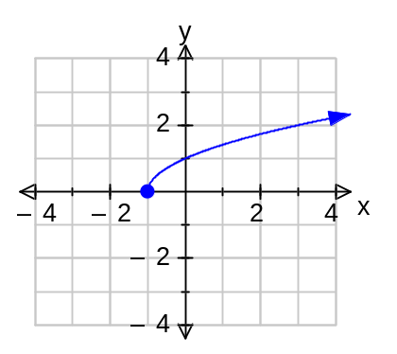  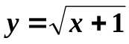 ✓✓ |  | b) | 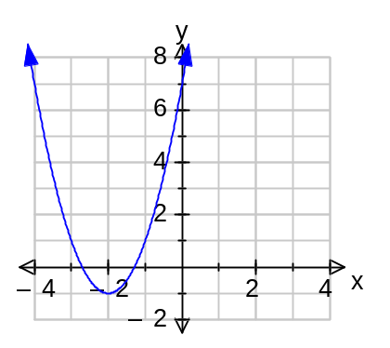  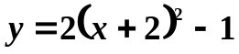 ✓✓
c) | 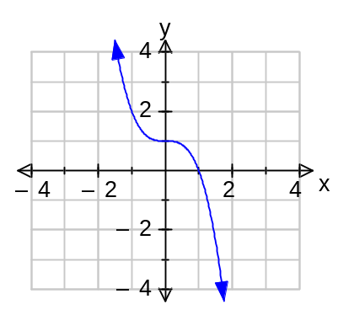  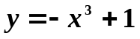 ✓✓ |  | d) | 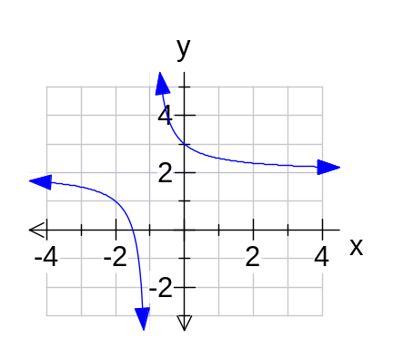  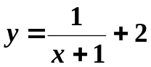 ✓✓

Question 2 [2, 3 marks]
- If X ~ N(2, 1) and Pr(X < k ) = 0.9772, then find the value of .

k= 3.9990 (4.d.p) ✓✓

- Two food manufacturers sell 650-gram cans of peas. Company A’s cans have a mean of 660 grams and a standard deviation of 7 grams, while Company B’s cans have a mean of 668 grams and a standard deviation of 14 grams. From which company are you more likely to get a can that weighs 650 grams or more?

For Company A
Pr(X > 650 ) = 0.9235 ✓

For Company B
Pr(X > 650) = 0.9008 ✓

Company A’s cans are preferable according to the given criteria. ✓

Question 3 [½, ½, 1, 2, 1 marks]

The Venn Diagram below shows the probabilities of events A and B occurring.
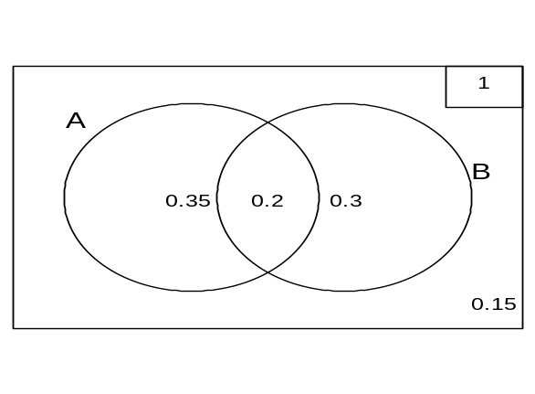 | Find:
 | a) 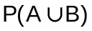 | = 0.85 | mk
 | b) 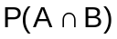 | = 0.2 | mk
 | c) 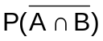 | = 0.8 | ✓
 | d) 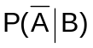 | = 0.6 | ✓
 | e) 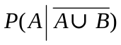 | = 0 | ✓
Question 4 [1, 2, 2, 1 marks]

Below are the graphs of the function 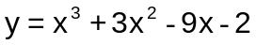

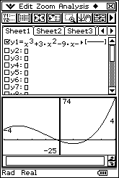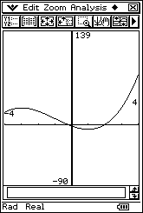

a) State the domain of the graph as shown in the diagrams above.

domain x: -4 ≤ x ≤ 4 ✓

b) Using an appropriate method:
i) State, to 1 d.p. where necessary, the coordinates of the x and y intercept(s) of the function over the given domain.

x intercepts: (-4.8, 0), (-0.2, 0) and (2, 0) ✓ -4.8 outside domain
y intercept: (0, -2) ✓

ii) Give the coordinates of any turning points over the given domain and state whether they are a maximum or a minimum.

max. t.p. : (-3, 25)✓
min. t.p. : (1, -7)✓

iii) Give the coordinates of any point(s) of inflection over the given domain.

(-1, 9)✓

Question 5 [3, 4 marks]

A researcher is looking for the links between grass allergies and eczema. 560 children where studied.

a) Complete the table.
 | Allergic to grass | Not Allergic to grass | TOTAL
Eczema positive | 300 | 172 | 472
No Eczema | 52 | 36 | 88
TOTAL | 352 | 208 | 560
✓✓✓ -1 / error

b) What is the probability that a randomly chosen child
i) Is allergic to grass? 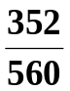 ✓

ii) Is not allergic to grass but does have Eczema? 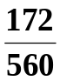 ✓

iii) Is not allergic to grass given they have Eczema? 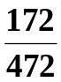 ✓✓

Question 6 [1, 1, 3 marks]

Let X be a random variable which is normally distributed with a mean of 10 and a standard deviation of 2. Find the following probabilities:

a) P(X = 10) = 0 ✓

b) P(8.5 ≤ X ≤ 9) = 0.0819 ✓

c) P(X ≥ 7 ⎢X ≤ 12) 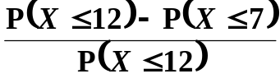
= 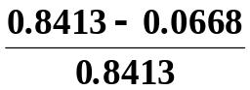 ✓
= 0.9206 ✓

Question 7 [4, 1, 1, 2, 2 marks]

The Sydney Harbour Bridge has a main steel arch in the shape of a parabola. If the base of the left pylon is taken as the origin then the height y of the arch is given by

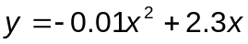, where x is the horizontal distance spanned, from the base of the left pylon.

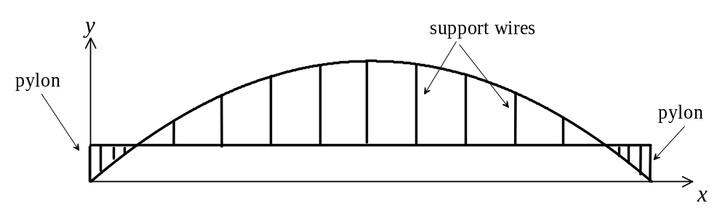
If the road is situated 40 metres above the base of the pylon, determine (to 2 decimal places):

a) i) where the arch meets the road
x = 18.95m ✓ and x = 211.05m ✓

ii) hence the length of road between the points where this occurs.

∴ Road length = 211.05 – 18.95m ✓ = 192.10m ✓

b) the maximum height of the arch above the road level.
Max height of arch = 132.25m
Max.ht. of arch = 132.25 – 40 = 92.25m ✓

c) If the bases of the pylons are at sea level and adjoin each bank, how wide is the expanse of water?
230 m ✓

d) What is the length of the support wires 50 metres from where the arch meets the road?

50 metres from where the arch meets the road is when
x = 68.95m and y = 111.04m ✓
∴ length of support wire = 111.04 – 40 = 71.04m ✓
e) If a worker is painting the arch, where will the worker be (measured from the left end of the arch) if they are 30 metres above the road?
i.e. when y = 70
x = 36.10m ✓ x = 193.90m ✓
Question 8 [4 marks]

Simplify and express with positive indices [Show All Working]

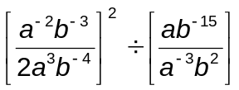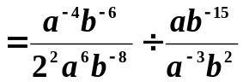 ✓
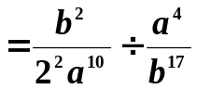 ✓✓
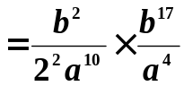 ✓
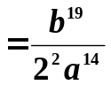 ✓

Question 9 [1, 2, 2 marks]

There are 6 people in Jodi’s family, four who drink tea and two who drink coffee. Jodi has purchased four new tea cups, two new coffee mugs and a matching sugar bowl and milk jug. Each cup and mug has the name of the person in the family who drinks from it printed on the front.

In how many ways can Jodi arrange, in a row, the 8 new items she has purchased on her china shelf if:

a) there are no restrictions. = 8 × 7 × 6 × 5 × 4 × 3 × 2 × 1 = 40 320 ✓

b) the sugar bowl must go on one end and the milk jug must go on the other end.

= 1 × 6 × 5 × 4 × 3 × 2 × 1 × 1 × 2 ✓
= 1 440✓
c) the tea cups must be grouped together, the coffee mugs must be grouped together, the sugar bowl and milk jug must be grouped together.
Consider 4 tea cups as 1 4 × 3 × 2 × 1 = 24
2 coffee mugs as one 2 × 1 = 2
sugar and milk jug as 1 2 × 1 = 2
then total number of arrangements = 24 × 2 × 2 × (3 × 2 × 1)
= 576 ✓✓

Question 10 [1, 1, 2 marks]

A tin of a new brand of coffee claims to hold 150 grams. In fact, the weight of the coffee in the tin is normally distributed with a mean of 151grams and a standard deviation of 2 grams.

Determine the probability that a tin of this brand of coffee holds

a) exactly 152 grams of coffee. = 0 ✓

b) at least 149 grams of coffee. = P(X > 149) = 0.84 ✓
c) at least 149 grams of coffee given that it holds no more than 152 grams.
= P(X > 149⎢X < 152) = 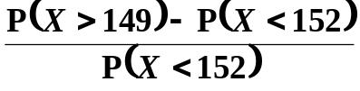
= 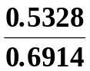 ✓
= 0.7705 ✓

Question 11 [5 marks]

The high school ‘Battle of the Bands’ is judged on three criteria: musical ability, T.V. Appeal and an audience vote. Two specialist judges give a rating on their area of speciality only (One judge per criterion) and there is an overall audience vote. Each category is rated out of 100 and a weighting is applied to each category.

The categories and weightings are as follows.

 |  | Categories
 | Musical Ability | T.V. Appeal | Audience Vote
Weights→ | 5 | 3 | 3
Dunridge SHS | 95 | 76 | 87
Belcraig SHS | 75 | 92 | 96
Leemton SHS | 98 | 57 | 46
Willing SHS | 65 | 98 | 92
Church Mod SHS | 84 | 94 | 92

Rank the schools in order with the school with the highest weighted mean ranked first. Show full working.

DSHS 95 × 5 + 76 × 3 + 87 × 3 = 964 ✓ ②
BSHS 75 × 5 + 92 × 3 + 96 × 3 = 939 ✓ ③
LSHS 98 × 5 + 57 × 3 + 46 × 3 = 799 ✓ ⑤
WSHS 65 × 5 + 98 × 3 + 92 × 3 = 895 ✓ ④
CMSHS 84 × 5 + 94 × 3 + 92 × 3 = 978 ✓ ①

Question 12 [1, 1, 1, 1 marks]

A Western Australian black swan has four cygnets (baby swans). They never travel far from their mother. Below is a graph of the movement of the mother swan. The distance she travels is in metres (m) from the nest and the time taken is in seconds (s).

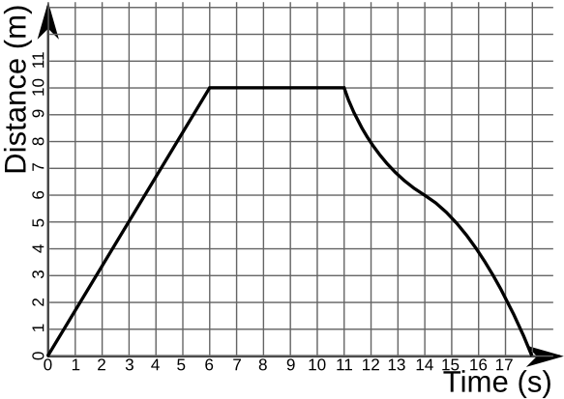
a) At one stage the cygnets were some distance from their mother and she travelled out to bring them back to the nest. How far were the cygnets from their mother?

10m ✓

b) At what speed did the mother swan travel to collect her cygnets?

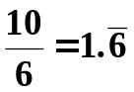 m/s ✓

c) How long did the mother swan stay to collect her cygnets?
5 secs✓

d) What was the average speed on the homeward journey

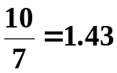 m/s ✓

Question 13 [3, 2, marks]

a) Clever Senior High School specialises in mathematics education. The Principal wishes to survey 150 of the student body using a stratified sample to determine how well the school is meeting their educational needs.

Year | 8 | 9 | 10 | 11 | 12
Student No. | 314 | 270 | 205 | 179 | 152

- Calculate the number of students to be surveyed from each year group. Show full working.

Year 8 = 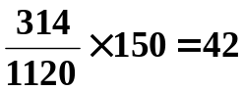 ✓
Year 9 = 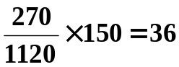 ✓
Year 10 = 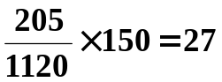 accept 28 ✓
Year 11 = 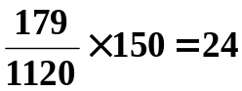 ✓
Year 12 = 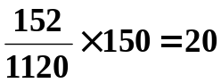 ✓

ii) Justify with clear reasoning why just using thirty students from each year would not give a representative sample.

Different proportion of students in each year group make up the school population.
Therefore, different proportion and hence number of students are required to represent each year group.✓✓

Question 14 [2 marks]

The Department of Environment and Conservation were needing data to determine if their fox baiting program at Wellington Dam had been successful. Evidence of this would be an increase in the numbers of previously endangered Chuditch (native cats). Field officers captured twenty Chuditch, tagged them and then released them. A sample of 30 that was subsequently recaptured included 4 tagged Chuditch. Assuming that this sample reasonably accurately reflects the total Chuditch population, calculate the total Chuditch population.

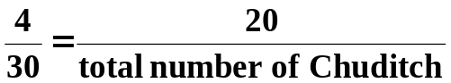 ✓
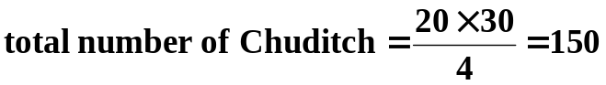 ✓

Question 15 [5 marks]
Amy sits for three tests scoring 56%, 87% and 65%. If the means are 60%, 75% and 51% respectively with corresponding standard deviations of 15.2, 9.3 and 6.5, standardise each test score and determine which test was her best effort.

Is Amy is improving in this subject?

Justifying your answer.

Test 1: 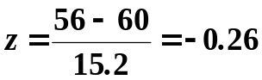 ✓
Test 2: 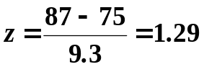 ✓
Test 3: 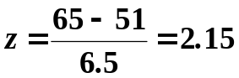 ✓

Test 3 was her best effort.

She improved with each test ✓

Spare Page

